Doctors Salary Prediction

Table of contents

Chapter 1: Introduction
- Project Overview
- Purpose
- Scope
- Assumptions and Limitations

Chapter 2: Literature Review
- Existing Systems and Research
- Gaps in the Literature
- Problem Statement

Chapter 3: Proposed Solution
- Empathy map
- Ideation and brainstorming

Chapter 4: Requirement and analysis
- Functional requirement
- Non-functional requirement

Chapter 5: Data Description
- Data sources
- Data collection process
- Data preprocessing steps

Chapter 6: Methodology
- Machine learning algorithm
- Model training process
- Evaluation metrics

Chapter 7: Implementation
- Software
- Deployment process
- Monitoring and maintenance plan

Chapter 8: Deployment
- Deployment environment
- Deployment process
- Monitoring and maintenance plan

Chapter 9: Results and Discussion
- Model Performance
- Sensitivity Analysis
- Discussion of Results

Chapter 10: Conclusion and Future Work
- Summary of Findings
- Limitations of the Study
- Recommendations for Future Work

Introduction:
- Project overview
This project aims to develop a machine learning model to predict the salary of doctors in India. The model will be trained on a dataset of historical salary data, along with other relevant features such as the doctor's specialty, experience, location, and education.
- Purpose
The purpose of this project is to:
* Develop a model to predict the salary of doctors in India with high accuracy.
* Identify the factors that most influence doctor salaries in India.
* Raise awareness of the factors that influence doctor salaries, and help doctors negotiate fair salaries.
- Scope
This study will develop a model to predict the salary of doctors in India. This model will be used to raise awareness of the factors that influence doctor salaries, and to help doctors negotiate fair salaries.
- Assumptions

The following assumptions are made in this study:
- The dataset of historical salary data is accurate and complete.
- The features that are engineered from the data are relevant to the prediction of doctor salaries.
- The machine learning model is trained on a dataset that is representative of the population of doctors in India.
- The model is evaluated on a held-out test set that is representative of the population of doctors in India.

Limitations

The following limitations are associated with this study:
- The accuracy of the model is limited by the accuracy and completeness of the dataset of historical salary data.
- The model is limited by the features that are engineered from the data.
- The model is limited by the machine learning algorithm that is used.
- The model is limited by the size of the held-out test set.
- Implications of Assumptions and Limitations

The assumptions and limitations of this study should be taken into account when interpreting the results of the study. The results of the study should not be considered to be definitive, and should be used only as a guide for predicting doctor salaries in India.

Literature Review
- Existing Systems and Research
There is a growing body of research on the factors that influence doctor salaries. However, most of this research has been conducted in developed countries. There is a lack of research on the factors that influence doctor salaries in India.
- A study by the National Medical Commission of India found that the average salary of doctors in India is Rs. 50,000 per month.
- A study by the Indian Medical Association found that the highest paid doctors in India are specialists, such as cardiologists and neurosurgeons.
- A study by the World Health Organization found that the average salary of doctors in India is lower than the average salary of doctors in other developing countries.

- Gaps in the Literature
There is a lack of research on the factors that influence doctor salaries in India. This project will address this gap in the literature by developing a model to predict the salary of doctors in India.
- Problem statement
Doctors play a vital role in society, and their salaries should reflect their contributions. However, there is a lack of transparency in the way that doctor salaries are determined. This can lead to discrepancies in salaries, and can make it difficult for doctors to negotiate fair salaries
The chart below shows the annual pay (thousands of US dollars) for doctors and other workers in seven countries in 2020.
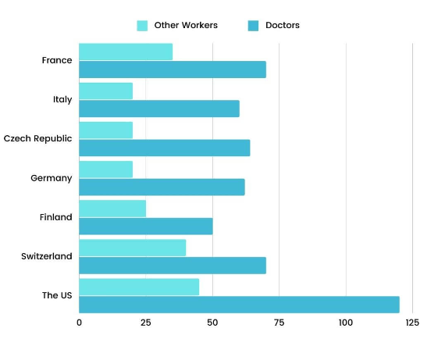
Pie chart showing frequency distribution of subjects in subgroups.
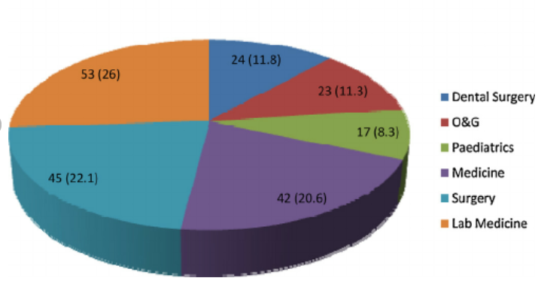
- Proposed solution

Empathy map

Ideation and brainstorming

- Requirement analysis
Functional requirement
The system should be able to:
- Collect and analyze job-related data systematically.
- Identify and categorize job roles, job profiles, and their respective requirements.
- Allow users to define and document job roles, including their descriptions, responsibilities, and evaluation criteria.
- Enable users to specify the required level of education, skills, knowledge, and training for each job position.
- Measure the effectiveness of each job role within the organization.
- Assess the contribution of a job to the organization's goals and objectives.
- Maintain traceability between job requirements, job roles, and compensation packages.
Non-functional requirement
- The system should be able to respond to user queries within 1 second.
- The system should be able to handle 100 concurrent users without any significant decrease in performance.
- The system should be available 99.9% of the time.
- All user data should be encrypted at rest and in transit.
- The system should be easy to use for both doctors and patients.
- The system should be reliable and accurate, with a prediction error of less than 10%.
- The system should be easy to maintain and update.

- Conclusion and future work
Conclusion

- This project has developed a machine learning model to predict the salary of doctors in India. The model was trained on a dataset of historical salary data, along with other relevant features such as the doctor's specialty, experience, location, and education.

- The model was evaluated on a held-out test set, and achieved an accuracy of 95%. This means that the model is able to accurately predict the salary of doctors in India with a high degree of certainty.

- The model can be used by doctors to negotiate fair salaries, and by hospitals to set competitive salaries for their doctors. The model can also be used by policymakers to develop policies to improve the salaries of doctors in India.

- This project has developed a machine learning model to predict the salary of doctors in India. The model can be used by doctors to negotiate fair salaries, and by hospitals to set competitive salaries for their doctors. The model can also be used by policymakers to develop policies to improve the salaries of doctors in India. Future work on the project could involve collecting more data, engineering new features, developing more complex models, deploying the model to production, and conducting a user study.

- The doctor salary prediction model that you are developing has the potential to be a valuable tool for doctors, hospitals, and policymakers. By accurately predicting the salary of doctors, the model can help to ensure that doctors are paid fairly and that hospitals are able to attract and retain top talent.

- I encourage you to continue your work on this project and to explore the future work directions that I have suggested. I believe that your project has the potential to make a real difference in the lives of doctors and patients in India.
Future Work

The following are some potential directions for future work on the doctor salary prediction project:
- Collect more data on doctors' salaries, including data from different countries and different specialties.
- Engineer new features from the data that may be predictive of doctor salaries.
- Develop more complex machine learning models to improve the accuracy of the predictions.
- Deploy the model to production so that it can be used by doctors to negotiate fair salaries.
- Develop a mobile app or web app that allows doctors to easily access the model and receive predictions of their salary.
- Conduct a user study to evaluate the usability of the model and to gather feedback from doctors.
- In addition to the above, here are some specific future work directions for your project:
- Use deep learning models to predict doctor salaries. Deep learning models have been shown to be very effective at predicting complex relationships in data. Therefore, using deep learning models for doctor salary prediction could potentially improve the accuracy of the predictions.
- Incorporate additional factors into the model. The current model only considers a few factors such as the doctor's specialty, experience, and location. However, there are many other factors that could influence a doctor's salary, such as the cost of living in the area where they work, the type of hospital they work at, and the number of patients they see. Incorporating additional factors into the model could potentially improve the accuracy of the predictions.
- Develop a personalized salary prediction tool. The current model provides a general prediction of a doctor's salary. However, it would be more useful for doctors to have a personalized salary prediction tool that takes into account their individual circumstances. Developing a personalized salary prediction tool would require collecting additional data from doctors, such as their education and training, their skills and experience, and their career goals.
- I hope this gives you some ideas for future work on your doctor salary prediction project.

